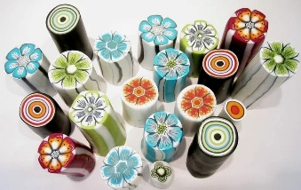
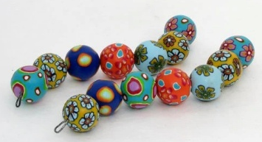
GLOUCESTERSHIRE FEDERATION OF WIS

POLYMER CLAY BEADS
TUESDAY 19TH MAY 2026

One of our most experienced tutors, Jane Cantwell, hosts this millefiori bead-making workshop. During the day you will learn the technique of ‘cane’ making, the main structure of these beads.
You will also have an extra option
to make some more abstract designs giving you more unusual and original beads.
After the curing process, you will have the opportunity
to make either a bracelet or necklace with the beads, to wear or as a gift.

VENUE: WI House, 2 Brunswick Square, Gloucester, GL1 1UL
Free Parking available at WI House.
DATE: Tuesday 19th May
TIME: 10am to 3.30pm
FEE: £35 per member, £40 per non-members
There is an additional charge of a maximum of £10 for materials used payable to the tutor on the day.
OTHER: Tea/ coffee provided throughout the day. Please provide a packed lunch.

Organiser: Pat Carpenter Closing Date: 24th April

NAME OF WI........................................................................

Contact Name ........................................................ Email: ..........................................

Name of Participants | Participants Email | Emergency Contact and  Phone Number

Total amount payable at @ £35 per member = £ ____________
Total amount payable at @ £40 per nonmember = £ ____________
Total: = £ ____________
Please make cheques payable to GFWI

Paid by BACS on (Quote ref ‘Beads’): ____________

IMPORTANT: Please be aware our BACS details recently have changed to the below:
The Gloucestershire Federation of Women’s Institutes CIO
Sort Code 402209, Account Number: 32805456

Please return this form to: GFWI, 2 Brunswick Square, Gloucester, GL1 1UL
or alternatively email your form to admin@gfwi.org.uk

