GLOUCESTERSHIRE FEDERATION OF WIS
A LITERARY TEA WITH MELANIE GOLDING
SATURDAY 10th OCTOBER 2026
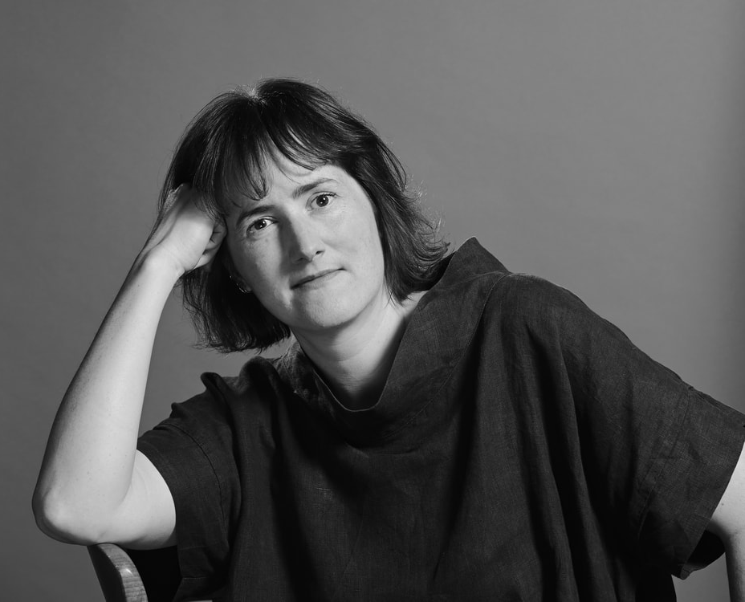
Come and enjoy hearing local author, Melanie Golding talk about her writing. Melanie is the author of three published novels: Little Darlings (2019), The Replacement (2021) and The Sight (2023). Little Darlings received national acclaim, was optioned for film, and translated into twelve languages, winning the Dragon Con Award for Best Horror Novel. Her second novel was a Barnes and Noble book of the month. Alongside writing, Melanie works as a freelance mentor for emerging fiction writers as well as lecturing in creative writing at Bath Spa University. Born in Leicestershire, Melanie has a wide- ranging interest in different styles of fiction and her new novel is set against the folklore of that county. Now living in Stroud, alongside her writing, Melanie is using her musical expertise with all ages in education and well-being. She leads ‘Sing Your Heart Out Stroud’ women’s choir as well as running adult singing retreats and working with young children in ‘Playcircle’ in a myriad of activities. A busy interesting lady! Following the talk, you will enjoy a full afternoon tea, sandwiches, cake and scones, prepared by WI members, so you know it will be good. The afternoon will finish with a book signing and opportunity to purchase Melanie’s books.

VENUE: Cadbury Hall, Lake Lane, Frampton on Severn, GL2 7HG
TIME: 2.00pm until 4.00pm
FEE: £20 per member and £21 per non-member
(Members will take priority should a ballot take place)
Includes Afternoon Tea
Organiser: Janice Cole Closing Date: 14th September

NAME OF WI........................................................................

Contact Name ........................................................ Email: ...................................................................

Names of Participants | Emergency Contact and  Phone Number | WI Member (Yes or No) | Dietaries

Total amount payable at @ £20 per member = £ ____________
Total amount payable at @ £21 per non-member = £ ____________
Total: = £ ____________
Please make cheques payable to GFWI
Paid by BACS on (Quote ref ‘Literary Tea‘) Date: ____________

The Gloucestershire Federation of Women’s Institutes CIO
Sort Code 402209, Account Number: 32805456

Please return this form to:
GFWI, 2 Brunswick Square, Gloucester, GL1 1UL or by email to admin@gfwi.org.uk

